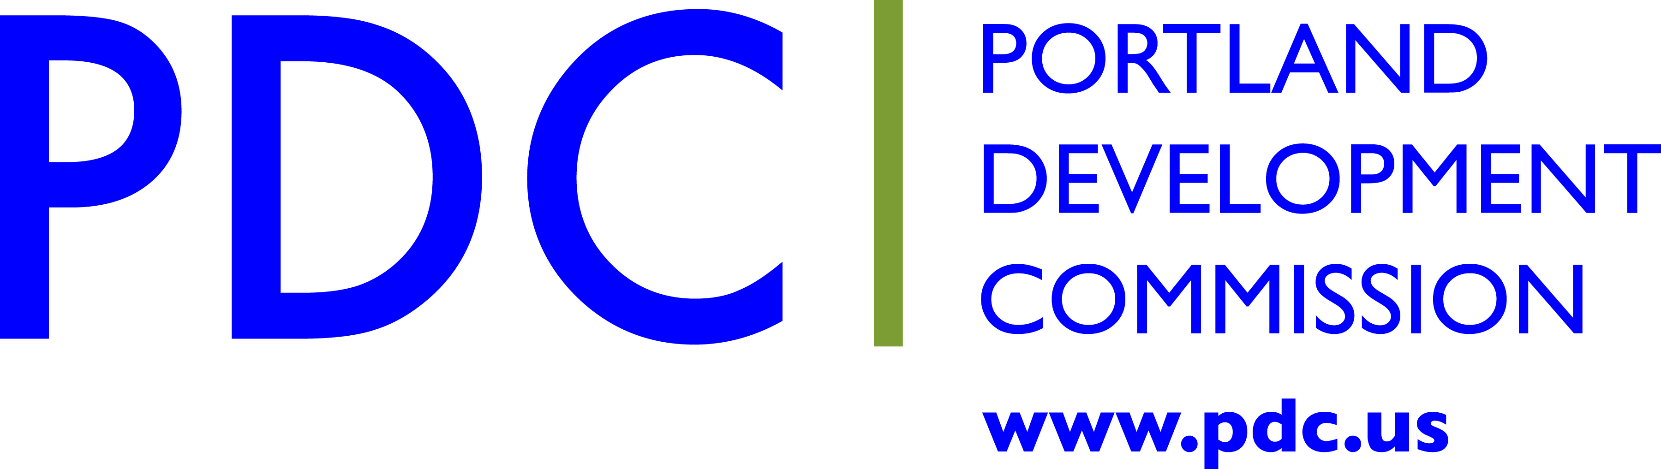

Lombard Street Investment Strategy
Fact Sheet
Lombard Street, designated as State Highway 30 bypass, is one of the few commercial corridors for the North Portland neighborhoods of Portsmouth, Kenton and Piedmont. In its current configuration as a four-lane, high-speed roadway, the street is viewed by the community primarily as a barrier between neighborhoods. It functions well for moving traffic, but poorly for supporting growth and livability for some 400 multi-ethnic business owners and residents who live and work along this 2.2-mile stretch of Lombard. The businesses and surrounding neighbors in Piedmont, Kenton and Arbor Lodge have long advocated for improvements to this street.

PDC has $1.5 million budgeted for infrastructure improvements on the 2.2-mile stretch. This will be supplemented with PDC’s storefront and pre-development (DOS) funds for local businesses and technical assistance provided by team partner the Hispanic Chamber of Commerce. All future project work needs to balance the desire for improvement and potential negative gentrification pressures.

Project Area | North Lombard Street, between North Chautauqua and North Williams (2.2 miles)
Project Purpose | Work with business, property owners and community to identify Lombard’s commercial strengths and key nodes along the corridor; implement targeted infrastructure improvements along these nodes while complying with Lombard’s state highway and freight corridor designations; support business growth and improve safety and livability on the street.
Project Budget (PDC) | $1.5 million for infrastructure; supplemented by programs which provide targeted business assistance such as storefront improvements, environmental and property redevelopment.
Timeline: | Phase I: 2014-15  Investment Strategy development: assessment, business capacity building, design & engineering of streetscape improvements  Phase II: 2016-17  Strategy Implementation/Capital Improvements
Project Partners | Oregon Department of Transportation (ODOT)  Portland Bureau of Transportation (PBOT)  Portland Bureau of Planning and Sustainability (BPS)  Bureau of Environmental Services (BES)  TriMet  Metro  Lombard business owners and community members.
Project Team | Michele Reeves, Civilis Consultants  Ken Pirie, Walker Macy Architects  Carlos Moreno, Hispanic Chamber of Commerce  Leila Aman; PDC Project Manager  Contact:503-823-3305; AmanL@pdc.us

Success Criteria
- Identification and future implementation of streetscape improvements at three to five key nodes that are feasible within funding and regulatory constraints
- Public support and advocacy for suggested projects
- Communities of color along Lombard are engaged and benefit from the work
- Community and business members take on leadership roles to move the district forward, both on their own and in collaboration with the city and PDC

